**GTF Build Manager**

**Overview**

A web based application which has capability to trigger Jenkin builds of

* Tosca scripts
* UFT scripts
* Selenium Scripts
* Jmeter Scripts

The build will be executed in Docker images and report will be displayed for the user, even a non-technical user can trigger test build and view the report.

The application is built on top of open source technologies only, so no costs involved.

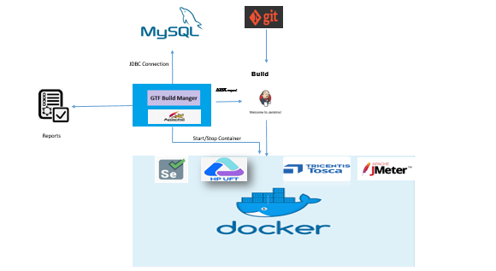

# Scenarios & Specification

***Login based on user role***

User can login to application with selecting user role providing passwords, currently there are

* Admin
* User

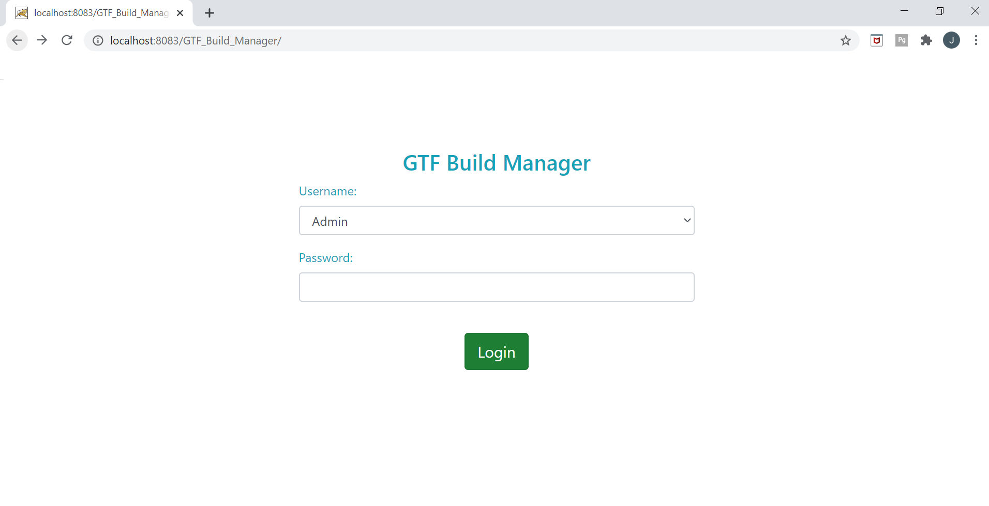

***Home Page***

* Home Page – User can view builds available and trigger builds/ builds will be triggered in Jenkins and execution will take place in Docker container.

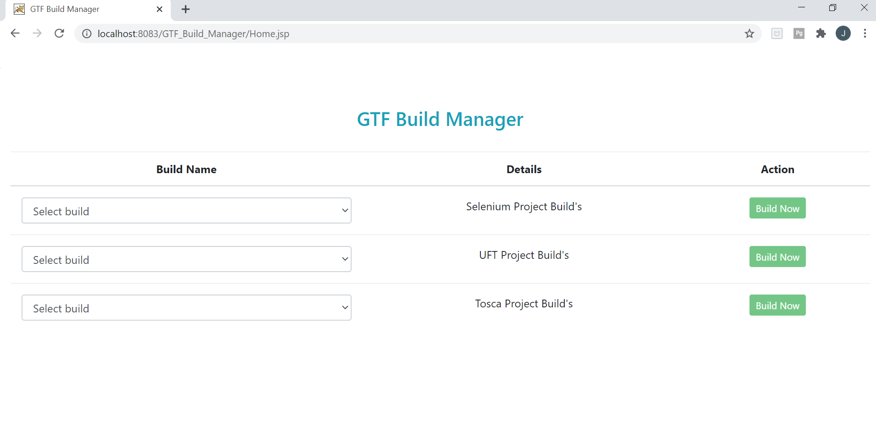

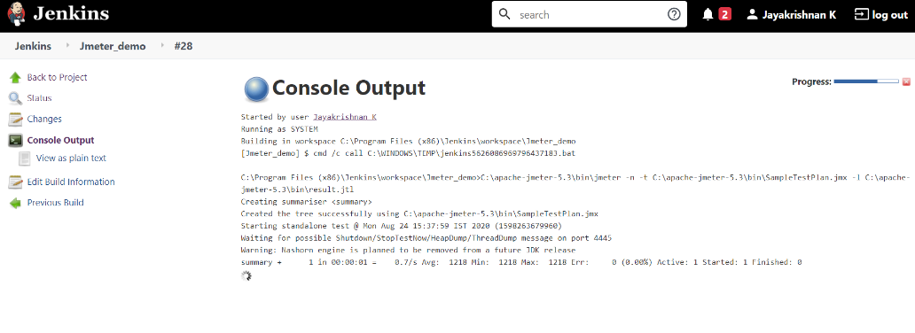

# Enhancements To-do

* Reporting feature
* UI Design
* MySql Db integration
* User Role Access and Restrictions

# Tools and Framework

* UI & Scripting
  + Bootstrap
  + Jquery
  + Ajax
* J2EE [ Java server pages [Jsp] , Servlets ]
* Apache Tomcat – Web server
* Apache Maven
* Jenkins
* Git
* Docker